E-Commerce
E-Commerce Case Study – Alibaba Subject: Adaptive Software Engineering Case Study
Selected Website: Alibaba
Name: M.Witty Roll: 2420030759

Alibaba is one of the world's largest international e-commerce platforms. It connects buyers and sellers from different countries. Customers can search for products, place orders, make secure payments, and track their deliveries. Businesses can also sell products to customers worldwide.

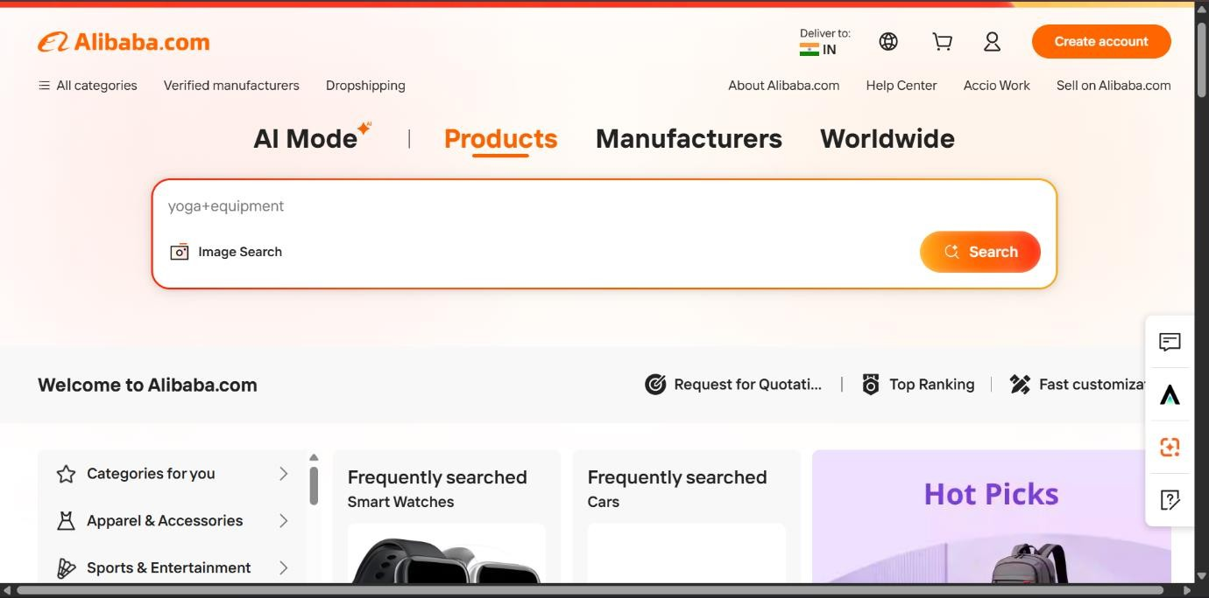

Understanding the System
Alibaba is an online shopping platform that helps buyers and sellers do business online. The system provides the following features:
  - User Registration and Login
  - Product Search
  - Product Categories
  - Shopping Cart

  - Online Payment
  - Order Tracking
  - Product Reviews and Ratings
  - Seller Dashboard

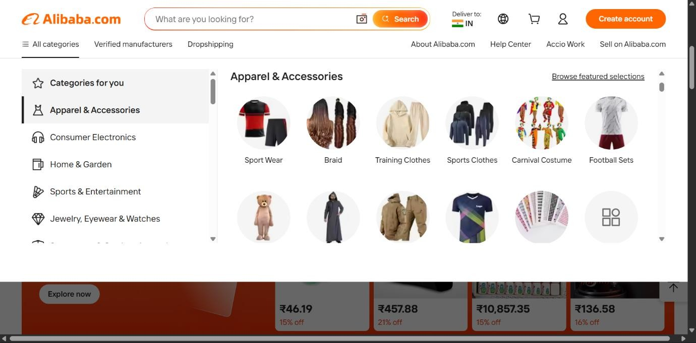
  - Customer Support

It makes online shopping simple, fast, and secure.

User Stories Customer
  - As a customer, I want to register and log in securely.
  - As a customer, I want to search for products.
  - As a customer, I want to add products to my shopping cart.
  - As a customer, I want to make secure online payments.
  - As a customer, I want to track my orders.
  - As a customer, I want to rate and review products.

Seller
  - As a seller, I want to add new products.
  - As a seller, I want to update product details.
  - As a seller, I want to manage inventory.

  - As a seller, I want to view customer orders.

Admin
  - As an admin, I want to manage customers.
  - As an admin, I want to manage sellers.
  - As an admin, I want to monitor orders.
  - As an admin, I want to generate sales reports.

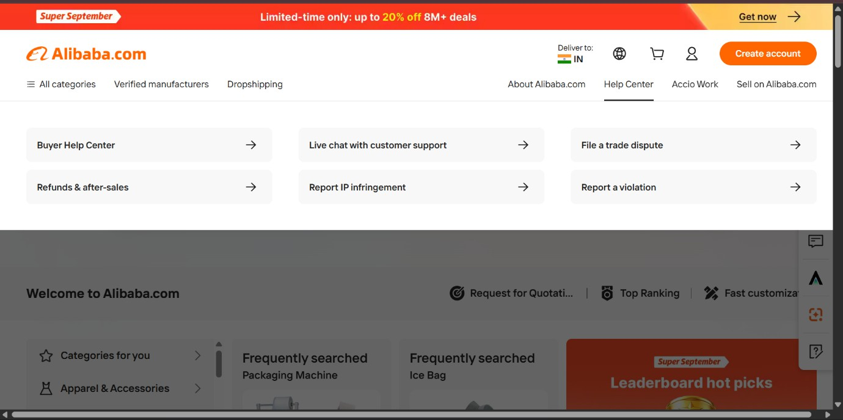

Software Development Process Model Selected Model: Agile Model
Reason:
  - Easy to add new features.
  - Changes can be made quickly.
  - Regular testing improves software quality.
  - Customer feedback can be added in every update.
  - Suitable for e-commerce websites because customer requirements change frequently.

Programming Language Frontend
  - HTML
  - CSS

  - JavaScript
  - React

Backend
  - Java (Spring Boot)

Database
  - MySQL
These technologies help build a fast, secure, and user-friendly e-commerce application.

Implementation Strategy
- Gather customer and seller requirements.
- Design the database and user interface.
- Develop modules such as Login, Product Management, Shopping Cart, Payment, and Order Tracking.
- Connect the frontend with the backend.
- Test every module.
- Deploy the application.
- Improve the system based on user feedback.

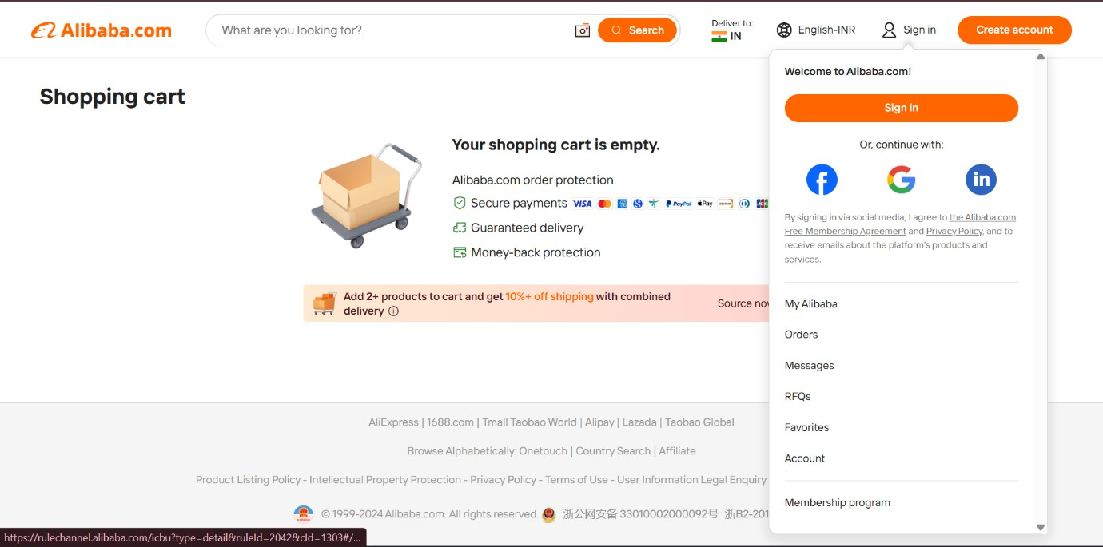

Evaluation Strategy
The e-commerce system will be evaluated by checking:

  - User registration and login work correctly.
  - Product search gives accurate results.
  - Shopping cart functions properly.
  - Online payment is secure.
  - Orders can be tracked successfully.
  - The website loads quickly.
  - User information is secure.
  - Customers find the website easy to use.

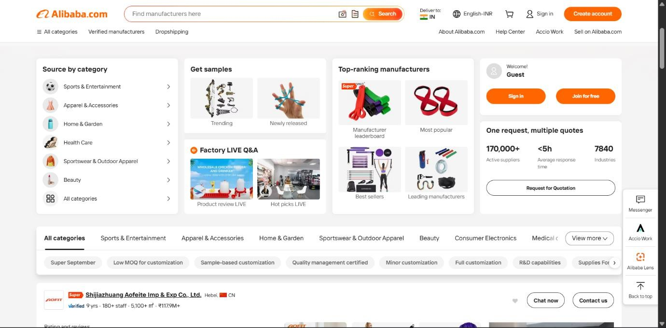

Expected Outcomes
  - Secure online shopping platform.
  - Fast product search.
  - Reliable order management.
  - Secure online payments.
  - Easy product management for sellers.
  - Better customer satisfaction.
  - Scalable system for future improvements.

Conclusion

Alibaba is a successful international e-commerce platform that provides secure online shopping, fast order processing, and reliable product management. Using the Agile Software Development Model helps improve the system by adding new features and fixing issues based on customer feedback.

